7.78: a)
b) 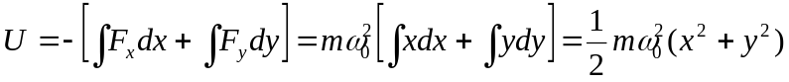
c)
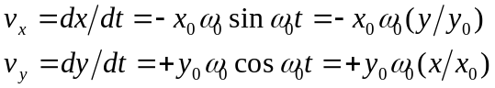
(i) When 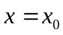 and 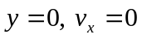 and 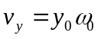
(ii) When  and 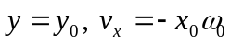 and 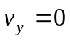
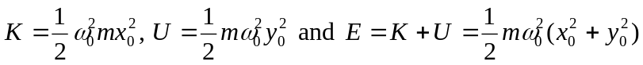
Note that the total energy is the same.

